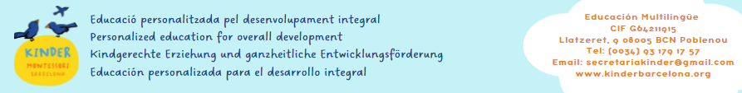

ANNEX TO THE REGISTRATION

Easter Camp 2023

Child’s name:

I agree to:
1. The following services and the corresponding fees:

 |  | Children MKB/ siblings |  | External children
Schedule |  | 1st child | brothers/sisters | 1st child | brothers/sisters
Early bird | 08.00 a 09.00 hrs | 20 € | 19 € | 21 € | 20 €
Total for the 4 days | From 09.00 to 14.00 hrs with meal and nappies | 104 € | 100 € | 109 € | 105 €
 | From 09.00 to 17.00 hrs  with meal and nappies | 136 € | 132 € | 141 € | 137 €

2. The resulting amount in euros to be paid according to the conditions of registration and payment of which I am aware:
Week/Days | 09.00 to 14.00 hrs  (food and nappies) |  | 09.00 to 17.00 hrs  (food and nappies) | 08.00 to 09.00 hrs
4 days (03.04 a 06.04.23)
Monday 03.04.23
Tuesday 04.04.23
Wednesday 05.04.23
Thursday 06.04.23
TOTAL |  | €

Registration fee: it is not charged in any case.
The discounts are not cumulative.

3. The following enrolment and payment conditions:
a. The payment will be made by direct debit at the time of registration.
b. The registration form must be filled in and signed in paper format.
c. The amounts paid will not be refunded in case of non-attendance, except in the case of illness with medical justification, in which case 50% of the amount paid will be refunded.
d. The schedules are fixed and divided into two shifts: 9-14 h and 9-17 hrs.
e. The Association reserves the right of admission and permanence of the children, as well as the right to not open or to close courses due to lack of vacancies and to change the location if convenient.

4. My son/daughter has to bring with himself/herself:

-The first day: a change of clothes and slippers.

-Every day: a backpack with their breakfast and/or snack.
Everything that children bring from home must be marked with their name (including shoes, slippers, etc.).
5. My son/daughter will participate with my consent and knowledge in this Easter Camp. I hereby agree to all the contents of this enrolment form.
Barcelona,………………………………………20…………………….
Name and surname:
Signature:

